**II. Phase: Business Process Modeling (Related to Management Information Systems - MIS)**

**1. Scope Definition**

**Business Process:**

Managing waste collection requests from residents and businesses, scheduling waste pickup, and logging service completion.

**Relevance to MIS:**

This process involves capturing service requests, coordinating resources (e.g., trucks, personnel), and tracking performance metrics, core MIS functions.

**Objective:**

Automate waste collection flow, monitor collector activities, and generate reports for decision-making.

**Expected Outcomes:**

* Faster service response
* Efficient scheduling
* Digital tracking of performance
* Reduced manual errors

**2. Key Entities (Actors and Systems)**

| **Entity** | **Role/Responsibility** |
| --- | --- |
| Resident/Business | Submit waste pickup requests |
| Admin (Municipality) | Reviews, approves, and schedules requests |
| Waste Collector | Fulfills assigned pickups and logs completion |
| System Database | Stores requests, schedules, logs, user info |
| Notification System | Sends reminders and alerts |

**3–5. Diagram with Swimlanes, UML Notation, and Logical Flow**

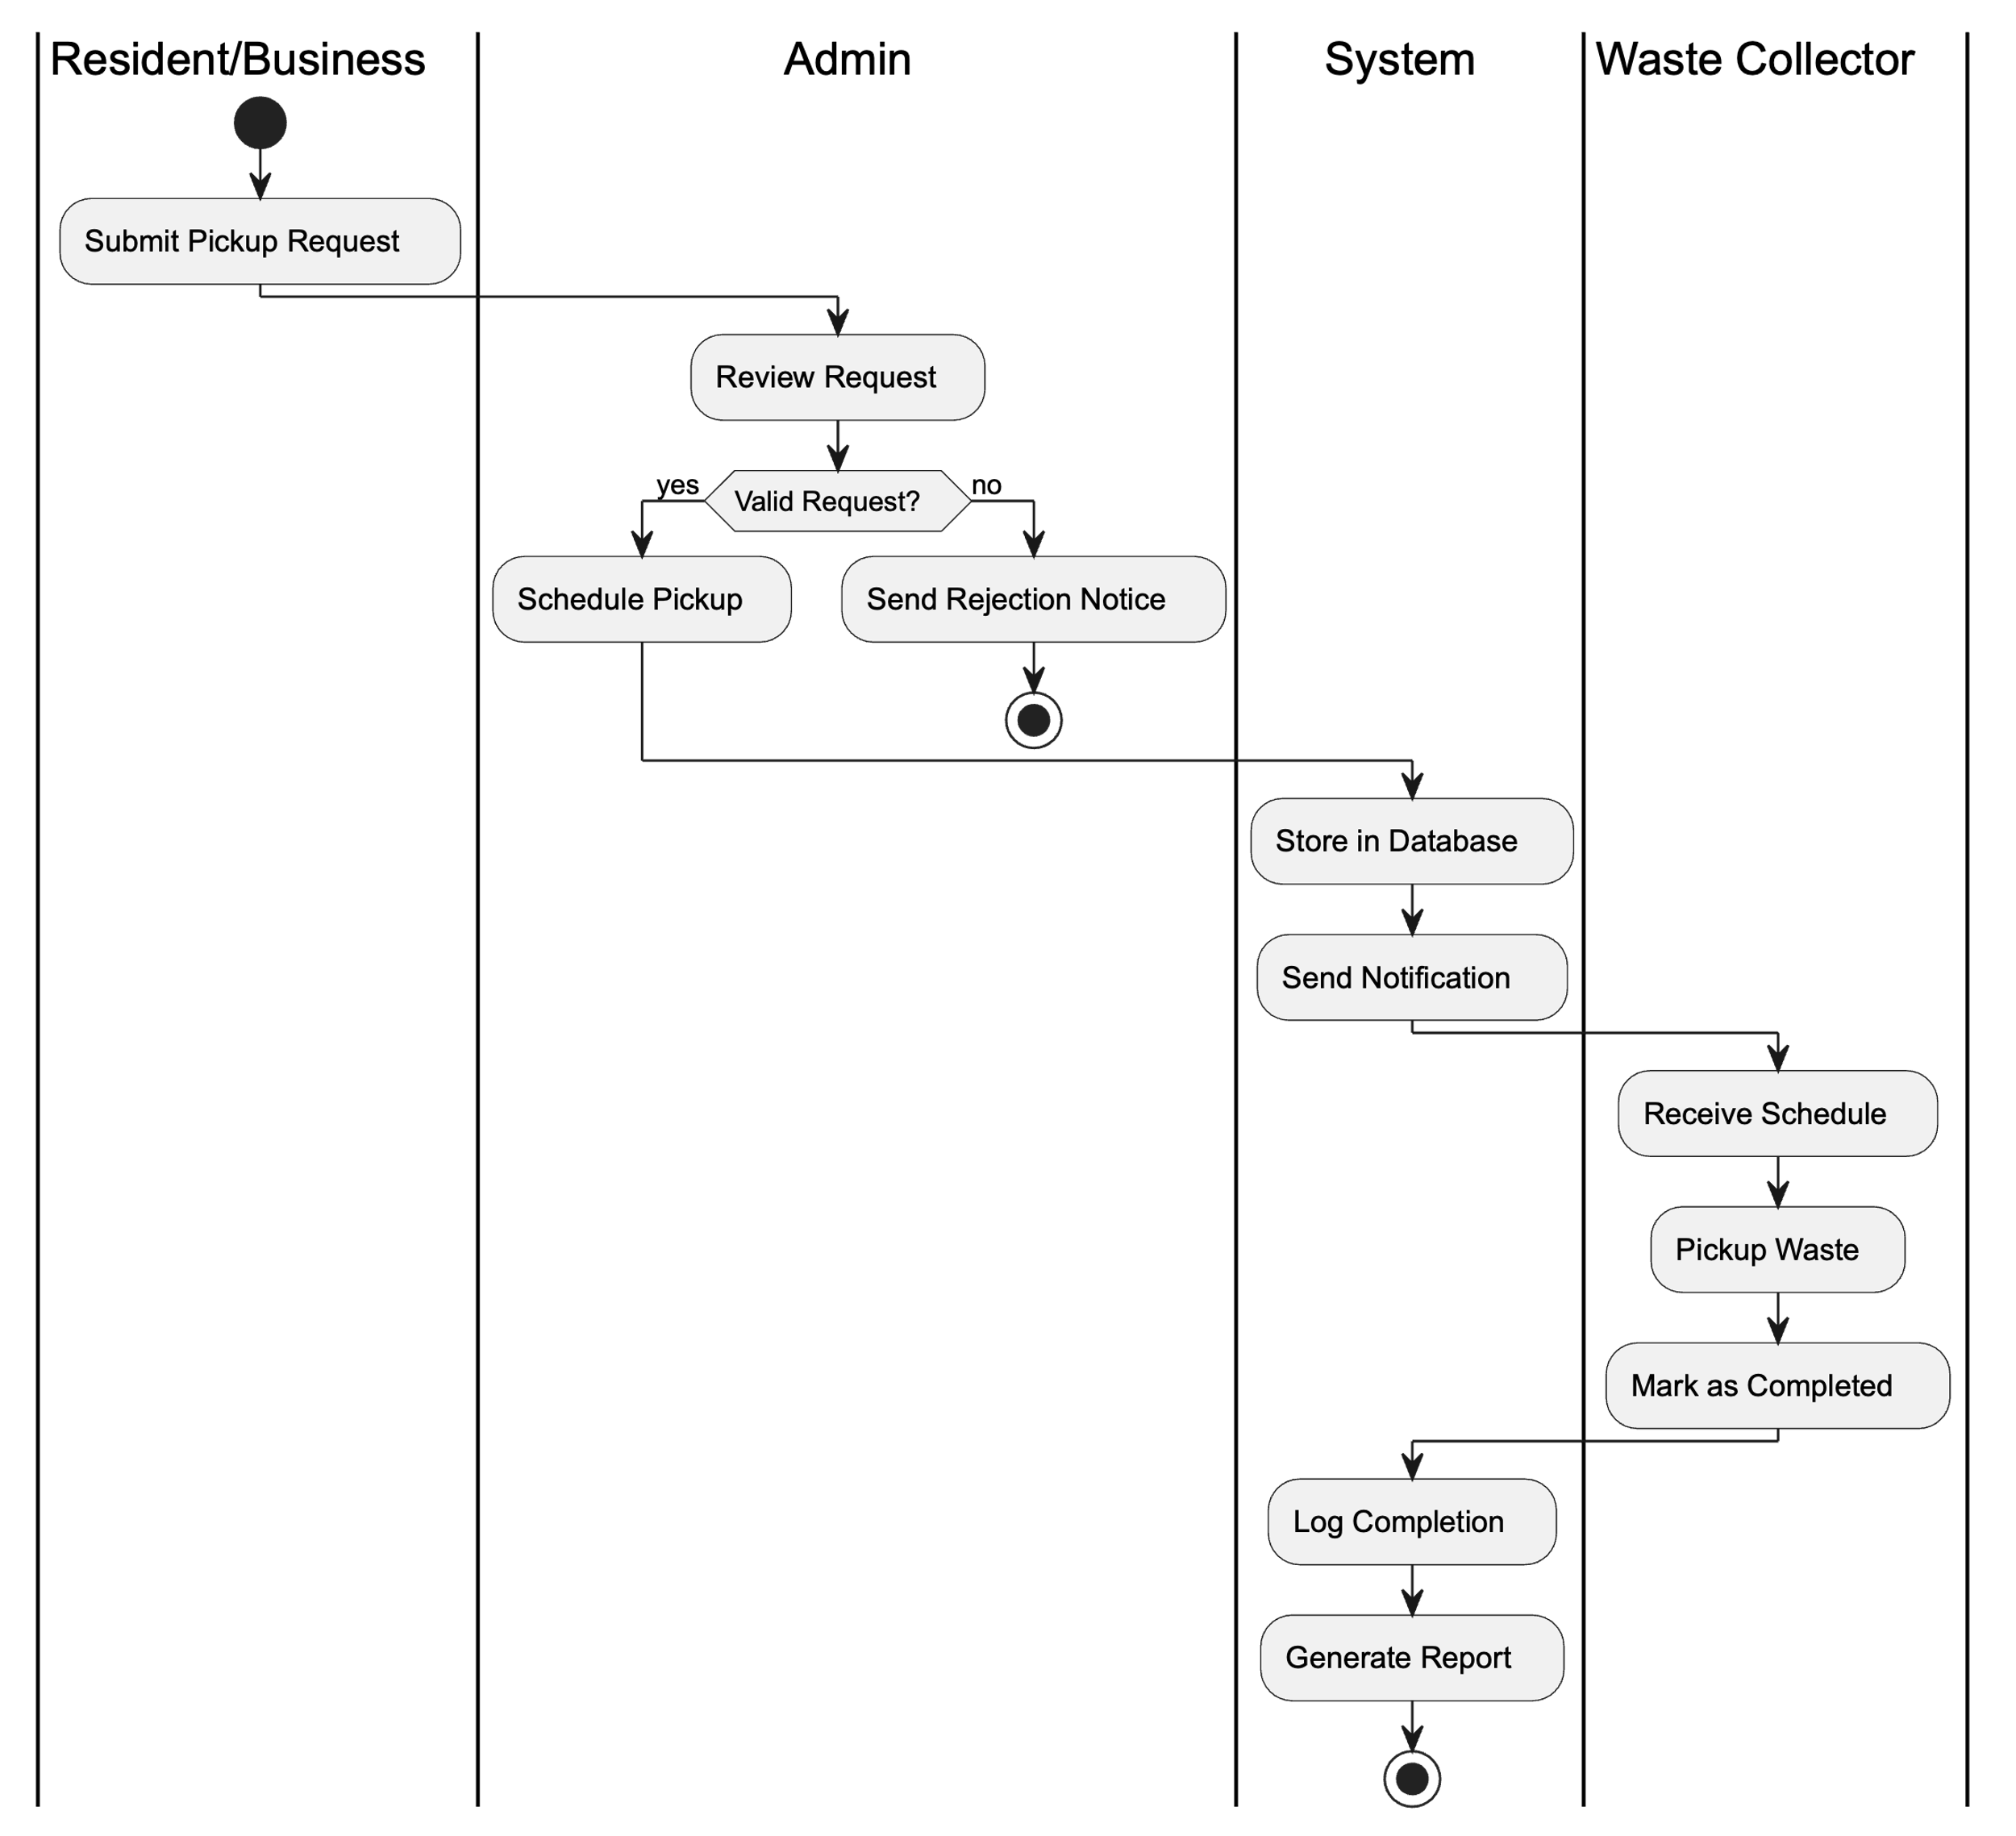

**6. Brief Explanation (for your report)**

The diagram models the waste collection process starting from the resident’s request to the final report generation. It includes key actors like the Admin, Waste Collector, and the automated system.

This system supports **MIS** by ensuring timely scheduling, digital record-keeping, and real-time reporting. It improves **decision-making** through analytics on request frequency, collector performance, and complaint resolution.

The process enhances **operational efficiency** by reducing manual coordination and delays, ensuring accountability via logs and reporting.

**III. Phase: Logical Model Design**

**1. Entity-Relationship (ER) Model**

In this section, we define the main entities involved in the Waste Management System and their key attributes, data types, and relationships.

**1.1. Identified Entities and Attributes**

| **Entity** | **Attributes** |
| --- | --- |
| **User** | user_id (PK), name, email, phone, user_type, location |
| **Waste_Request** | request_id (PK), user_id (FK), request_date, status |
| **Collector** | collector_id (PK), name, phone, vehicle_id (FK) |
| **Vehicle** | vehicle_id (PK), plate_number, capacity_kg, status |
| **Schedule** | schedule_id (PK), request_id (FK), collector_id (FK), scheduled_date, actual_collection_date, status |
| **Complaint** | complaint_id (PK), user_id (FK), request_id (FK), message, complaint_date, status |

Each attribute is associated with a proper data type (e.g., NUMBER, VARCHAR2, DATE) as per Oracle PL/SQL standards.

**2. Relationships & Constraints**

**2.1 Relationships Between Entities**

* **User – Waste_Request**: One user can submit many requests (1-to-many).
* **Waste_Request – Schedule**: One request has one schedule (1-to-1).
* **Collector – Schedule**: One collector can be assigned to multiple schedules (1-to-many).
* **Collector – Vehicle**: One collector uses one vehicle (1-to-1).
* **Waste_Request – Complaint**: A request may have many complaints (1-to-many).
* **User – Complaint**: A user can file multiple complaints (1-to-many).

**2.2 Constraints Applied**

* **Primary Keys**: All tables have defined primary keys to uniquely identify each record.
* **Foreign Keys**: Relationships are enforced using foreign key constraints.
* **NOT NULL**: Applied to mandatory fields like user_id, request_date, etc.
* **UNIQUE**: Enforced on fields like email, plate_number.
* **CHECK**: Applied to fields like status and user_type to ensure valid values.
* **DEFAULT**: Used to assign initial values to fields like status.

**3. Normalization**

All database tables are designed to follow the **Third Normal Form (3NF)**:

* **1NF**: All attributes hold atomic values.
* **2NF**: All non-key attributes are fully dependent on the primary key.
* **3NF**: No transitive dependencies exist between non-key attributes.

This ensures **data integrity, reduced redundancy**, and better **scalability**.

**4. Handling Data Scenarios**

The logical model supports a wide range of realistic scenarios, including:

* Users submitting multiple requests across different dates and locations.
* Assigning collectors to overlapping schedules.
* Allowing users to file complaints against specific requests.
* Vehicle reuse tracking and capacity monitoring.
* Tracking request statuses through multiple stages (Pending, Approved, Completed, etc.)

**5. ER Diagram**

Below is the ER diagram for the Waste Management System, modeled using Draw.io:

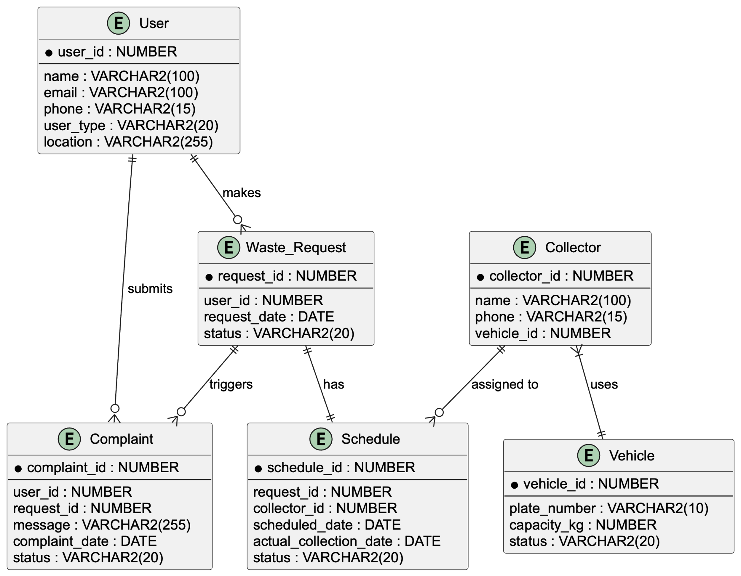

**IV. Phase: Database (Pluggable Database) Creation and Naming**

**1. Database Creation in Oracle**

**🧾 Naming Convention**

Your pluggable database should be named as:

mon_27901_vanessa_wastemgt_db

**🔐 Password**

Use your **first name** as the password:

Password: vanessa

**📜 SQL Script to Create the Database User and Assign Privileges**

Here’s a basic SQL block you can execute in Oracle SQL*Plus or SQL Developer:

-- Create user

CREATE USER mon_27901_vanessa_wastemgt_db

IDENTIFIED BY jeandd;

-- Grant DBA privileges (super admin)

GRANT CONNECT, RESOURCE, DBA TO CREATE USER mon_27901_vanessa_wastemgt_db

-- Optionally, set default tablespace and quota (recommended)

ALTER USER mon_27901_vanessa_wastemgt_db DEFAULT TABLESPACE USERS;

ALTER USER mon_27901_vanessa_wastemgt_db QUOTA UNLIMITED ON USERS;

⚠️ Make sure you are logged in as a user with **ADMIN privileges** (e.g., SYSDBA) to run these commands.

**2. Oracle Enterprise Manager (OEM) Setup**

You need to:

* Log in to **Oracle Enterprise Manager**.
* Connect to the **PDB (Pluggable Database)** you created.
* Monitor the following:
  + Tablespace usage
  + Session statistics
  + SQL activity (like DML and DDL)

**📸 Screenshot Tips for GitHub Submission**

When you reach this step, capture screenshots that clearly show:

* Your **database name** (mon_27901_vanessa_wastemgt_db)
* The **OEM dashboard overview**
* Any **SQL activity logs**, session reports, or metrics
* **User creation confirmation**

Make sure the **screenshots are clean and readable** before pushing them to GitHub.

**✅ Summary for Report**

You can write this in your report under **Phase IV**:

**Phase IV: Database Creation and Monitoring**

As part of this phase, a pluggable database namedmon_27901_vanessa_wastemgt_db was created using Oracle. A privileged user was defined with the username matching the database name and the password set to the student's first name for compliance with the naming convention.

To manage and monitor the database, Oracle Enterprise Manager (OEM) was configured. It tracks database health, session activity, resource usage, and query logs. Screenshots from OEM are provided in the GitHub repository to verify setup and user activity.

The user was granted full DBA privileges to allow creation and testing of PL/SQL components such as procedures, functions, triggers, and packages in later phases.

**V: Physical Database Implementation**

**1. Table Creation – SQL DDL Statements**

Here's a full PL/SQL script to create all the necessary tables with proper data types, primary/foreign keys, and constraints:

-- USER table

CREATE TABLE Users (

user_id NUMBER PRIMARY KEY,

name VARCHAR2(100) NOT NULL,

email VARCHAR2(100) UNIQUE NOT NULL,

phone VARCHAR2(15),

user_type VARCHAR2(20) CHECK (user_type IN ('Resident', 'Business', 'Admin')),

location VARCHAR2(255)

);

-- VEHICLE table

CREATE TABLE Vehicles (

vehicle_id NUMBER PRIMARY KEY,

plate_number VARCHAR2(10) UNIQUE NOT NULL,

capacity_kg NUMBER NOT NULL,

status VARCHAR2(20) DEFAULT 'Active'

);

-- COLLECTOR table

CREATE TABLE Collectors (

collector_id NUMBER PRIMARY KEY,

name VARCHAR2(100) NOT NULL,

phone VARCHAR2(15),

vehicle_id NUMBER UNIQUE,

CONSTRAINT fk_vehicle FOREIGN KEY (vehicle_id) REFERENCES Vehicles(vehicle_id)

);

-- WASTE_REQUEST table

CREATE TABLE Waste_Requests (

request_id NUMBER PRIMARY KEY,

user_id NUMBER NOT NULL,

request_date DATE NOT NULL,

status VARCHAR2(20) CHECK (status IN ('Pending', 'Approved', 'Rejected', 'Completed')),

CONSTRAINT fk_user FOREIGN KEY (user_id) REFERENCES Users(user_id)

);

-- SCHEDULE table

CREATE TABLE Schedules (

schedule_id NUMBER PRIMARY KEY,

request_id NUMBER UNIQUE NOT NULL,

collector_id NUMBER NOT NULL,

scheduled_date DATE,

actual_collection_date DATE,

status VARCHAR2(20) CHECK (status IN ('Scheduled', 'Missed', 'Collected')),

CONSTRAINT fk_request FOREIGN KEY (request_id) REFERENCES Waste_Requests(request_id),

CONSTRAINT fk_collector FOREIGN KEY (collector_id) REFERENCES Collectors(collector_id)

);

-- COMPLAINT table

CREATE TABLE Complaints (

complaint_id NUMBER PRIMARY KEY,

user_id NUMBER NOT NULL,

request_id NUMBER NOT NULL,

message VARCHAR2(255),

complaint_date DATE DEFAULT SYSDATE,

status VARCHAR2(20) DEFAULT 'Open',

CONSTRAINT fk_comp_user FOREIGN KEY (user_id) REFERENCES Users(user_id),

CONSTRAINT fk_comp_request FOREIGN KEY (request_id) REFERENCES Waste_Requests(request_id)

);

2. Sample Data Insertion – SQL DML Statements

-- Users

INSERT INTO Users VALUES (1, 'Alice Johnson', 'alice@mail.com', '078000001', 'Resident', 'Sector 1');

INSERT INTO Users VALUES (2, 'GreenTech Ltd', 'info@greentech.com', '078000002', 'Business', 'Industrial Zone');

-- Vehicles

INSERT INTO Vehicles VALUES (1, 'RAB123A', 2000, 'Active');

INSERT INTO Vehicles VALUES (2, 'RAC567B', 1500, 'Active');

-- Collectors

INSERT INTO Collectors VALUES (1, 'John Doe', '0781111111', 1);

INSERT INTO Collectors VALUES (2, 'Jane Smith', '0782222222', 2);

-- Waste Requests

INSERT INTO Waste_Requests VALUES (101, 1, TO_DATE('2025-05-01', 'YYYY-MM-DD'), 'Pending');

INSERT INTO Waste_Requests VALUES (102, 2, TO_DATE('2025-05-02', 'YYYY-MM-DD'), 'Approved');

-- Schedules

INSERT INTO Schedules VALUES (1001, 101, 1, TO_DATE('2025-05-03', 'YYYY-MM-DD'), NULL, 'Scheduled');

INSERT INTO Schedules VALUES (1002, 102, 2, TO_DATE('2025-05-04', 'YYYY-MM-DD'), TO_DATE('2025-05-04', 'YYYY-MM-DD'), 'Collected');

-- Complaints

INSERT INTO Complaints VALUES (5001, 1, 101, 'Trash was not picked on time', TO_DATE('2025-05-04', 'YYYY-MM-DD'), 'Open');

**3. Data Integrity Measures Applied**

* **Primary keys** ensure entity uniqueness.
* **Foreign keys** enforce relational integrity.
* **UNIQUE** and **CHECK** constraints ensure valid and non-duplicate values.
* **DEFAULT** values prevent NULLs where optional data applies.

All inserted data reflects real-world use cases: missed pickups, scheduled collections, valid email formats, and meaningful complaint messages.

**Phase V: Table Implementation and Data Insertion**

In this phase, the logical model was translated into a physical Oracle database structure. Six tables were created: Users, Vehicles, Collectors, Waste_Requests, Schedules, and Complaints.

Each table includes appropriate data types, constraints, and relationships. Sample data was inserted to support real-world testing and to validate system operations, such as scheduling pickups, assigning collectors, and recording complaints.

Constraints such as NOT NULL, UNIQUE, CHECK, and DEFAULT were applied to ensure data integrity and consistency. The design supports practical scenarios like rejected requests, pending schedules, and complaint tracking, ensuring reliability for all project use cases.

**VI: Database Interaction and Transactions**

**1. DML and DDL Operations**

**✅ DDL Example – Add New Column**

ALTER TABLE Waste_Requests ADD description VARCHAR2(255);

**✅ DML Examples**

-- INSERT

INSERT INTO Waste_Requests VALUES (103, 1, SYSDATE, 'Pending', 'Extra pickup needed');

-- UPDATE

UPDATE Waste_Requests SET status = 'Completed' WHERE request_id = 101;

-- DELETE

DELETE FROM Complaints WHERE complaint_id = 5001;

**2. Problem Statement for Analytics Task**

“Determine the total number of waste pickups performed per collector per month, and find the collector with the highest number of collections.”

This will be used in a **function** using **window functions**.

**3. Stored Procedure: Fetch User Complaints**

CREATE OR REPLACE PROCEDURE GetComplaintsByUser (

p_user_id IN NUMBER

)

IS

CURSOR comp_cursor IS

SELECT complaint_id, message, status

FROM Complaints

WHERE user_id = p_user_id;

v_id Complaints.complaint_id%TYPE;

v_msg Complaints.message%TYPE;

v_status Complaints.status%TYPE;

BEGIN

OPEN comp_cursor;

LOOP

FETCH comp_cursor INTO v_id, v_msg, v_status;

EXIT WHEN comp_cursor%NOTFOUND;

DBMS_OUTPUT.PUT_LINE('Complaint ID: ' || v_id || ', Message: ' || v_msg || ', Status: ' || v_status);

END LOOP;

CLOSE comp_cursor;

EXCEPTION

WHEN OTHERS THEN

DBMS_OUTPUT.PUT_LINE('Error occurred: ' || SQLERRM);

END;

✅ Use EXEC GetComplaintsByUser(1); to test it.

**4. Function with Window Function: Top Collector by Count**

CREATE OR REPLACE FUNCTION TopCollector RETURN VARCHAR2 IS

v_name VARCHAR2(100);

BEGIN

SELECT name INTO v_name

FROM (

SELECT c.name, COUNT(*) AS total,

RANK() OVER (ORDER BY COUNT(*) DESC) AS rk

FROM Collectors c

JOIN Schedules s ON c.collector_id = s.collector_id

GROUP BY c.name

) WHERE rk = 1;

RETURN v_name;

EXCEPTION

WHEN NO_DATA_FOUND THEN

RETURN 'No data';

WHEN OTHERS THEN

RETURN 'Error: ' || SQLERRM;

END;

✅ Use SELECT TopCollector FROM dual; to call it.

**5. Package Example: Waste_Analytics_PKG**

CREATE OR REPLACE PACKAGE Waste_Analytics_PKG AS

PROCEDURE PrintAllComplaints;

FUNCTION CountRequestsByUser(p_user_id NUMBER) RETURN NUMBER;

END Waste_Analytics_PKG;

/

CREATE OR REPLACE PACKAGE BODY Waste_Analytics_PKG AS

PROCEDURE PrintAllComplaints IS

CURSOR cur IS SELECT user_id, message FROM Complaints;

v_user Complaints.user_id%TYPE;

v_msg Complaints.message%TYPE;

BEGIN

FOR rec IN cur LOOP

DBMS_OUTPUT.PUT_LINE('User: ' || rec.user_id || ' | Message: ' || rec.message);

END LOOP;

END;

FUNCTION CountRequestsByUser(p_user_id NUMBER) RETURN NUMBER IS

v_count NUMBER;

BEGIN

SELECT COUNT(*) INTO v_count

FROM Waste_Requests

WHERE user_id = p_user_id;

RETURN v_count;

EXCEPTION

WHEN OTHERS THEN

RETURN -1;

END;

END Waste_Analytics_PKG;

✅ Test with:

EXEC Waste_Analytics_PKG.PrintAllComplaints;

SELECT Waste_Analytics_PKG.CountRequestsByUser(1) FROM dual;

**✅ Summary for Report**

In this phase, core interactions with the database were developed using PL/SQL. This includes:

- Executing DML (Insert, Update, Delete) and DDL (Alter) commands.

- Creating reusable procedures with cursor loops to fetch user complaint data.

- Writing analytical functions with window functions to retrieve top-performing collectors.

- Encapsulating logic into a package `Waste_Analytics_PKG` that groups related procedures and functions.

- Implementing error handling and exception capture for robustness.

The modular approach ensures clean code organization and easier maintenance.

**VII: Advanced Database Programming and Auditing**

**1. Problem Statement**

In our Waste Management System, we want to **enhance data integrity and security** by preventing unauthorized table modifications during **weekdays (Mon–Fri)** and **public holidays**. We also aim to **track all critical DML operations** (INSERT, UPDATE, DELETE) for accountability.

**Justification**

* Triggers help us **enforce business rules** at the database level.
* Auditing mechanisms allow tracking **who did what and when**.
* A holiday reference table ensures the system respects operational calendars.

**2. Reference Table for Holidays**

CREATE TABLE Holidays (

holiday_date DATE PRIMARY KEY,

description VARCHAR2(100)

);

-- Sample data (upcoming month)

INSERT INTO Holidays VALUES (TO_DATE('2025-06-01', 'YYYY-MM-DD'), 'Independence Day');

INSERT INTO Holidays VALUES (TO_DATE('2025-06-16', 'YYYY-MM-DD'), 'National Cleanup Day');

**3. Auditing Table**

CREATE TABLE Audit_Log (

log_id NUMBER GENERATED ALWAYS AS IDENTITY PRIMARY KEY,

user_id NUMBER,

action_date DATE DEFAULT SYSDATE,

operation_type VARCHAR2(10),

object_name VARCHAR2(50),

status VARCHAR2(10)

);

**4. Security Trigger (Preventing DML on Weekdays and Holidays)**

CREATE OR REPLACE TRIGGER trg_block_dml

BEFORE INSERT OR UPDATE OR DELETE ON Waste_Requests

DECLARE

v_day VARCHAR2(10);

v_today DATE := SYSDATE;

v_holiday NUMBER;

BEGIN

SELECT TO_CHAR(v_today, 'DY') INTO v_day FROM dual;

SELECT COUNT(*) INTO v_holiday

FROM Holidays

WHERE holiday_date = TRUNC(v_today);

IF v_day IN ('MON', 'TUE', 'WED', 'THU', 'FRI') OR v_holiday > 0 THEN

RAISE_APPLICATION_ERROR(-20001, 'DML operations not allowed today.');

END IF;

END;

/

**5. Compound Trigger for Auditing**

CREATE OR REPLACE TRIGGER trg_audit_waste_requests

AFTER INSERT OR UPDATE OR DELETE ON Waste_Requests

FOR EACH ROW

BEGIN

INSERT INTO Audit_Log (user_id, operation_type, object_name, status)

VALUES (USERENV('SESSIONID'), CASE

WHEN INSERTING THEN 'INSERT'

WHEN UPDATING THEN 'UPDATE'

WHEN DELETING THEN 'DELETE'

END,

'Waste_Requests',

'allowed');

END;

/

**✅ Summary for Your Report**

This phase implemented advanced PL/SQL programming to automate operations and enforce business rules. A holiday table and trigger ensure no DML activity occurs during weekdays or national holidays. A compound trigger logs every change to the `Waste_Requests` table into an `Audit_Log`, capturing the user session, action, and timestamp.

These mechanisms enhance security, enable accountability, and align with MIS best practices for database-level enforcement and monitoring.

**GitHub Report Structure (Markdown Example)**

Create a README.md file in your GitHub repo with the following structure:

# Waste Management System – Capstone Project

**Course**: INSY 8311 - Database Development with PL/SQL

**Student**: HABIMANA Jean de Dieu

**Student ID**: 27901

## 🧠 Problem Statement

Urban areas lack centralized tools for monitoring waste pickups, complaints, and service efficiency. This project builds a PL/SQL-based Oracle database to automate workflows and improve operational control.

## 📊 Key Entities & Relationships

- Users, Waste Requests, Schedules, Vehicles, Collectors, Complaints

- Normalized to 3NF

- Includes constraints and auditing logic

## 🧱 SQL Scripts

Organized into phases:

- `phase_i_ii_overview.md`: Problem, Process Modeling

- `phase_iii_logical_model.puml`: ER Diagram

- `phase_v_tables_insertion.sql`

- `phase_vi_interactions.sql`

- `phase_vii_advanced_auditing.sql`

## 📸 Screenshots

- OEM setup

- Sample query results

- Trigger & audit logs

## ✅ Features

- PL/SQL Triggers to prevent actions on weekdays/holidays

- Audit table for logging operations

- Reusable packages and cursor-based procedures

## 🚀 Recommendations

- Add GIS integration

- Implement mobile collector tracking

- Use AI for smart scheduling

---

📂 Be sure to include `.sql`, `.puml`, and screenshots inside properly named folders (e.g., `/scripts`, `/diagrams`, `/screenshots`).

---

Let me know if you'd like help generating the `README.md` file or screenshots. You're now fully ready to complete Phase VIII and submit your capstone! ​:contentReference[oaicite:0]{index=0}​